**EXPERIMENT-2**

**NAME:** SHAIKH MUBASHIRA TUFEL AHMED

**ROLL NO:** 612055 **COURSE:** ADVANCE DEVOPS(ITL504)

**BRANCH:** T.E. INFORMATION TECHNOLOGY (SEM 5)

1. **What is S3 ?Explain Uses of S3.**

🡺Amazon S3 is an object storage service that stores data as objects within buckets. An *object* is a file and any metadata that describes the file. A *bucket* is a container for objects. Amazon Simple Storage Service (Amazon S3) is a scalable, high-speed, webbased cloud storage service. The service is designed for online backup and archiving of data and [applications](https://www.techtarget.com/searchsoftwarequality/definition/application) on Amazon Web Services (AWS). Amazon S3 was designed with a minimal feature set and created to make web-scale computing easier for developers.

Amazon S3 can be used by organizations ranging in size from small businesses to large enterprises. S3's scalability, availability, security and performance capabilities make it suitable for a variety of data storage use cases. Common use cases for S3 include the following:

* Data storage;
* Data archiving;
* Application [hosting](https://www.techtarget.com/searchstorage/definition/cloud-hosting) for deployment, installation and management of web apps;
* Software delivery;
* Data backup;
* Disaster recovery ([DR)](https://www.techtarget.com/searchdisasterrecovery/definition/disaster-recovery);
* Running [big data analytics](https://www.techtarget.com/searchbusinessanalytics/definition/big-data-analytics) tools on stored data;
* [Data lakes;](https://www.techtarget.com/searchaws/definition/data-lake)
* Mobile applications;
* Internet of things ([IoT)](https://internetofthingsagenda.techtarget.com/definition/Internet-of-Things-IoT) devices;
* Media hosting for images, videos and music files
* Website hosting -- particularly well suited to work with [Amazon CloudFront](https://www.techtarget.com/searchaws/definition/Amazon-CloudFront) for content delivery.

1. **Deployment of static web site on AWS S3.**

**Step 1: AWS Management Console Dashboard.**

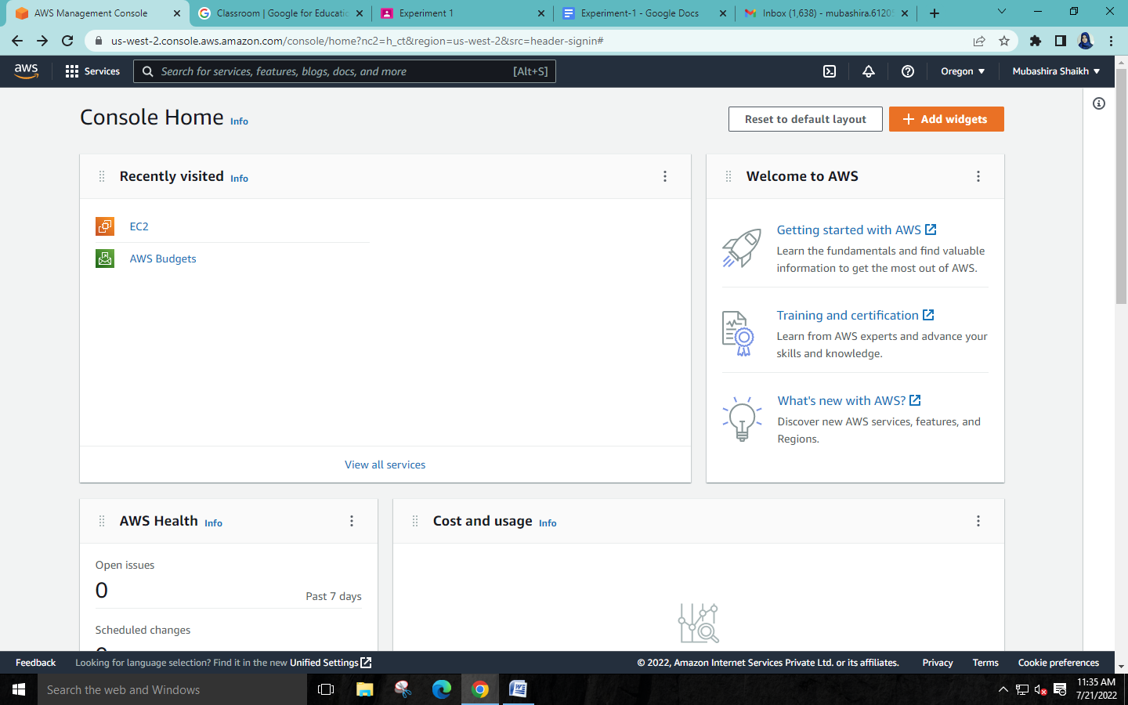

**Step 2:Click on Servises🡪Storage🡪S3**

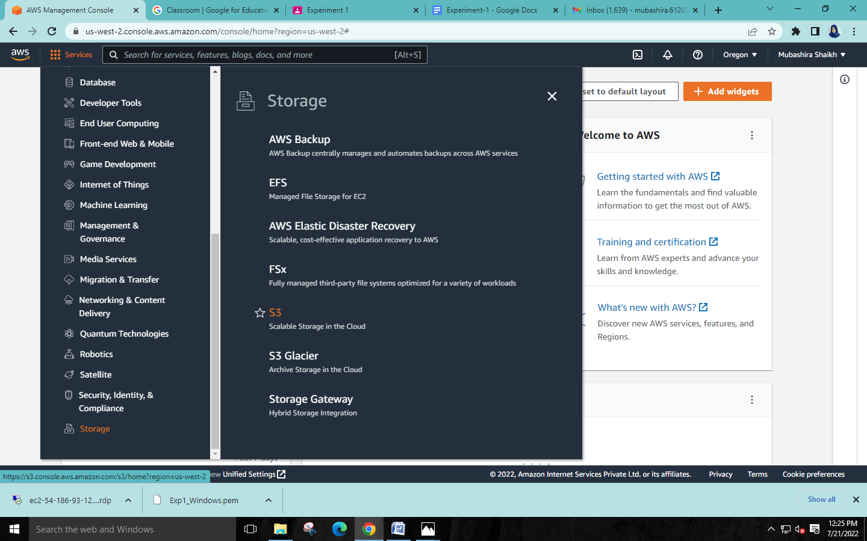

**Step 3:Click on ‘Create bucket’**

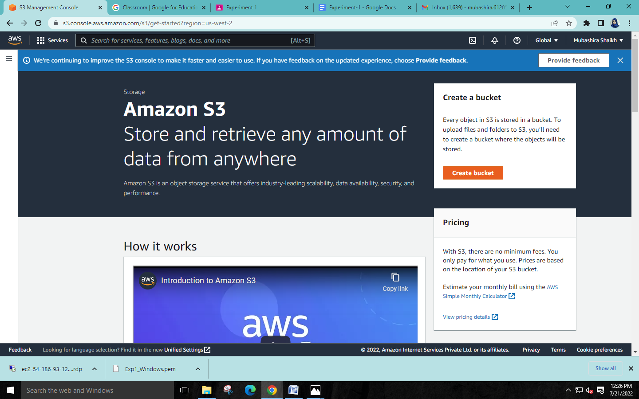

**Step 4:Give your bucket a name.**

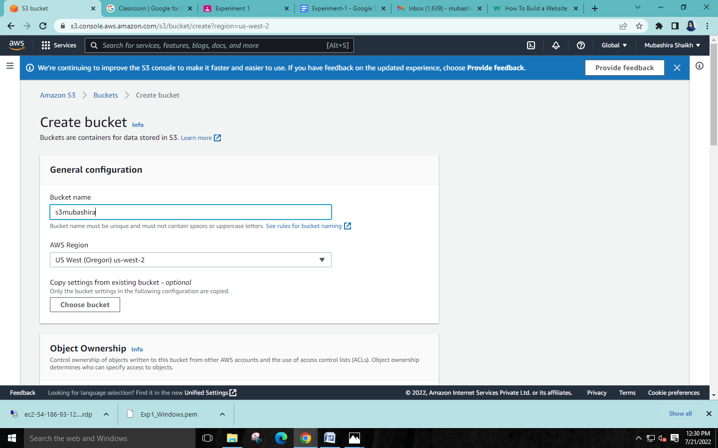

**Step 5: Uncheck the ‘Block all public access’ checkbox.**

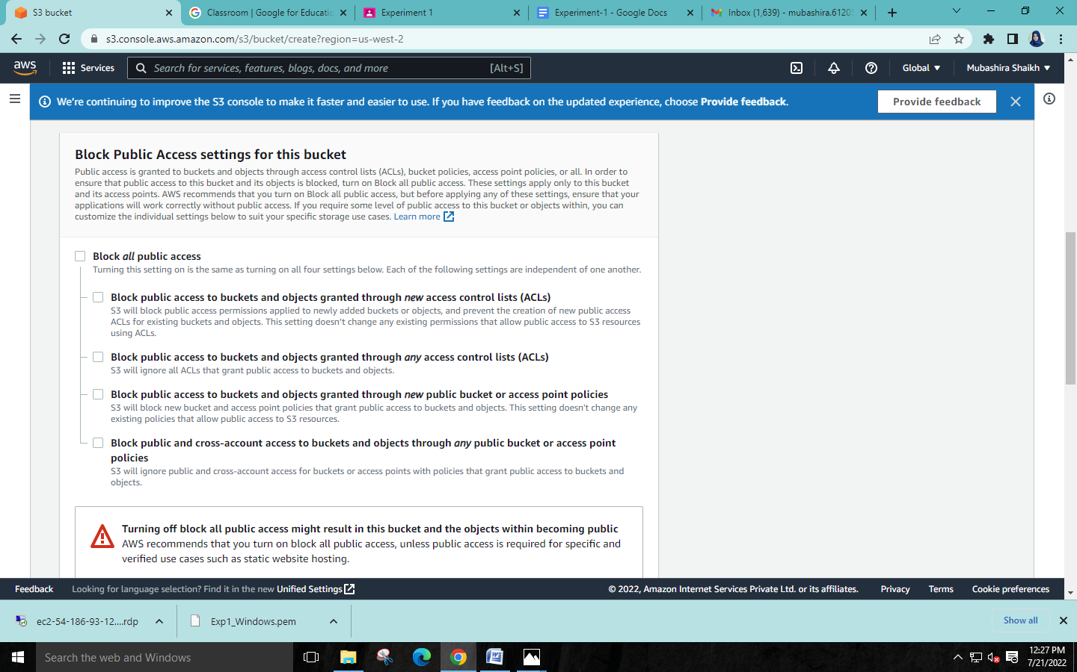

**Step 6: Select the bucket.**

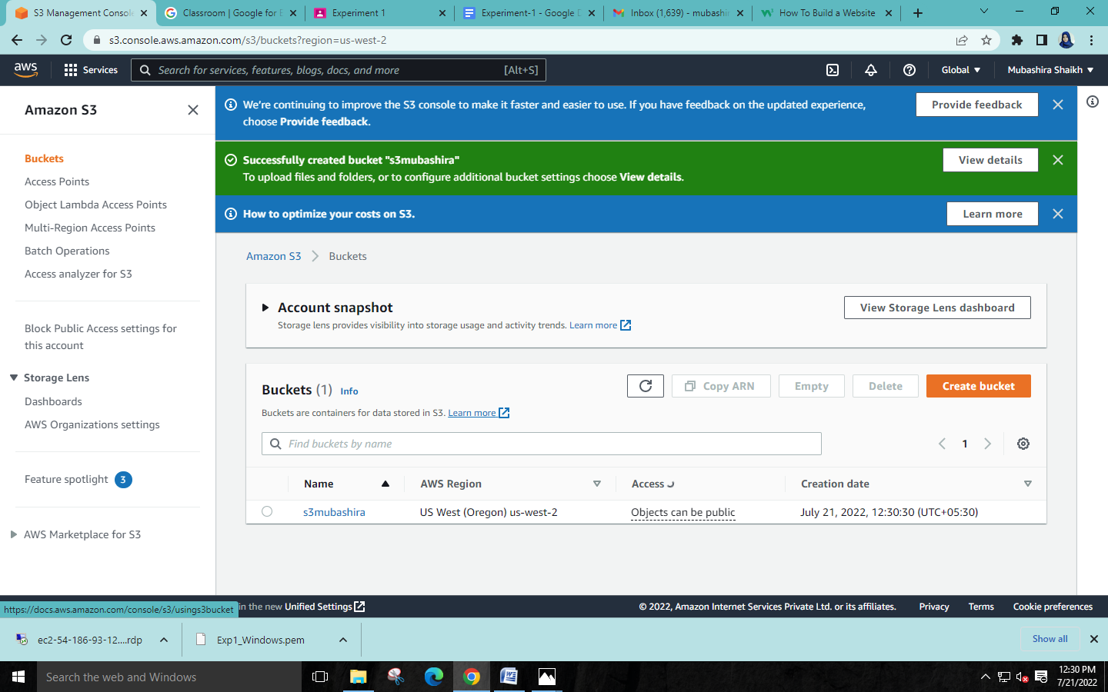

**Step 7: Properties 🡪Edit ‘Static Website Hosting’ 🡪 Select ‘Enable Static Website Hosting’.**

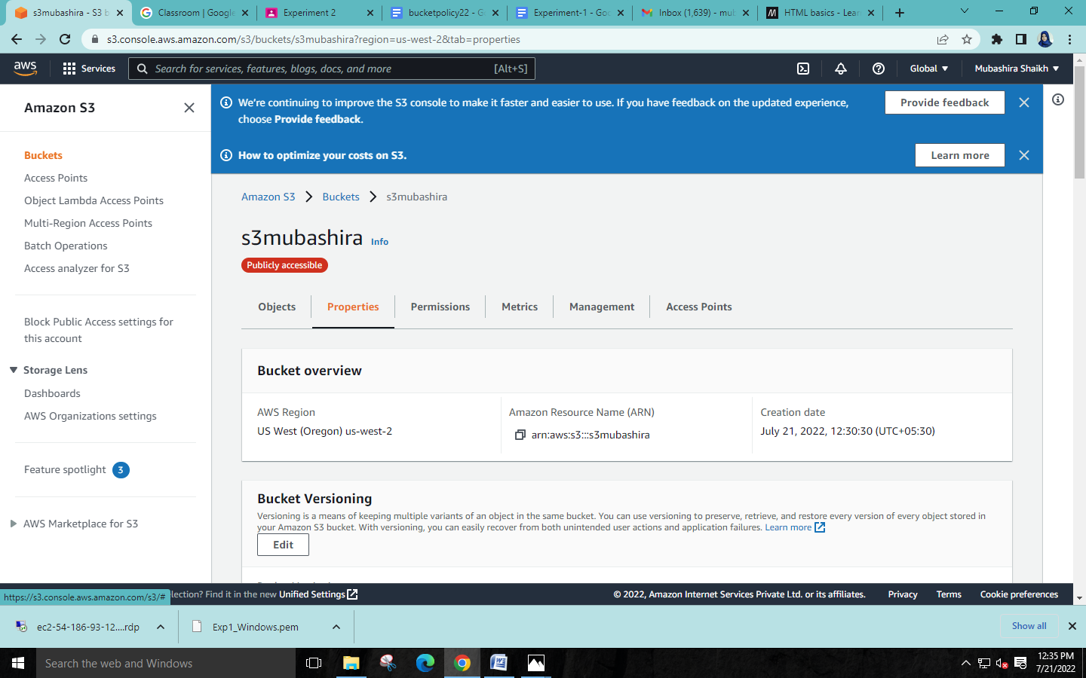

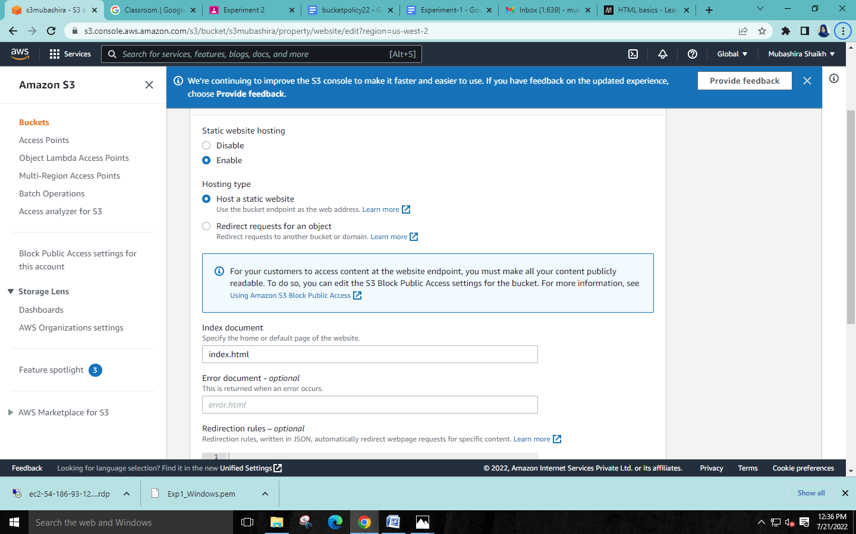

**Step 8: Permissions 🡪Edit the bucket policy section.**

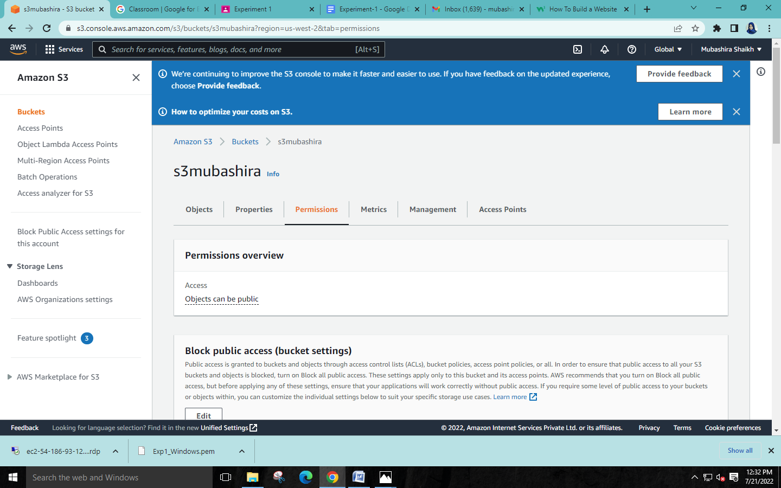

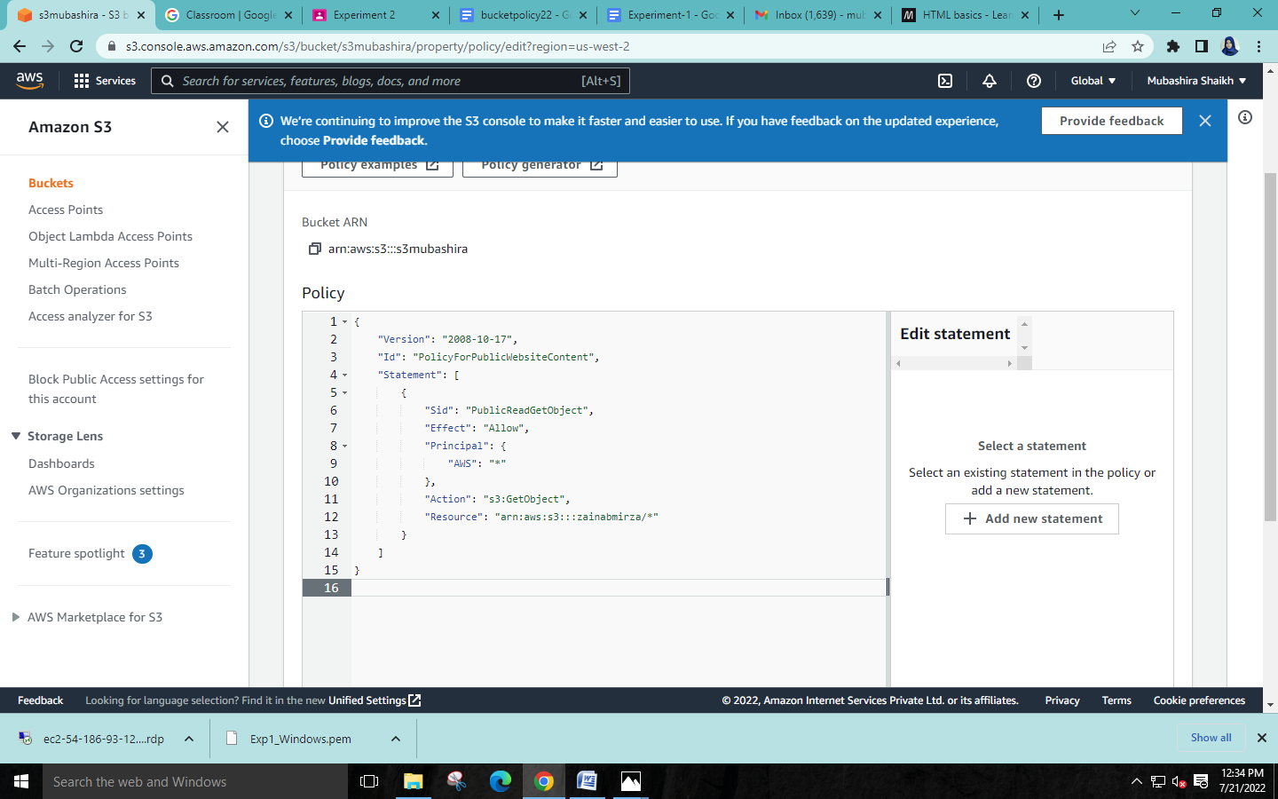

**Step 9: In the objects section attach the html code files.**

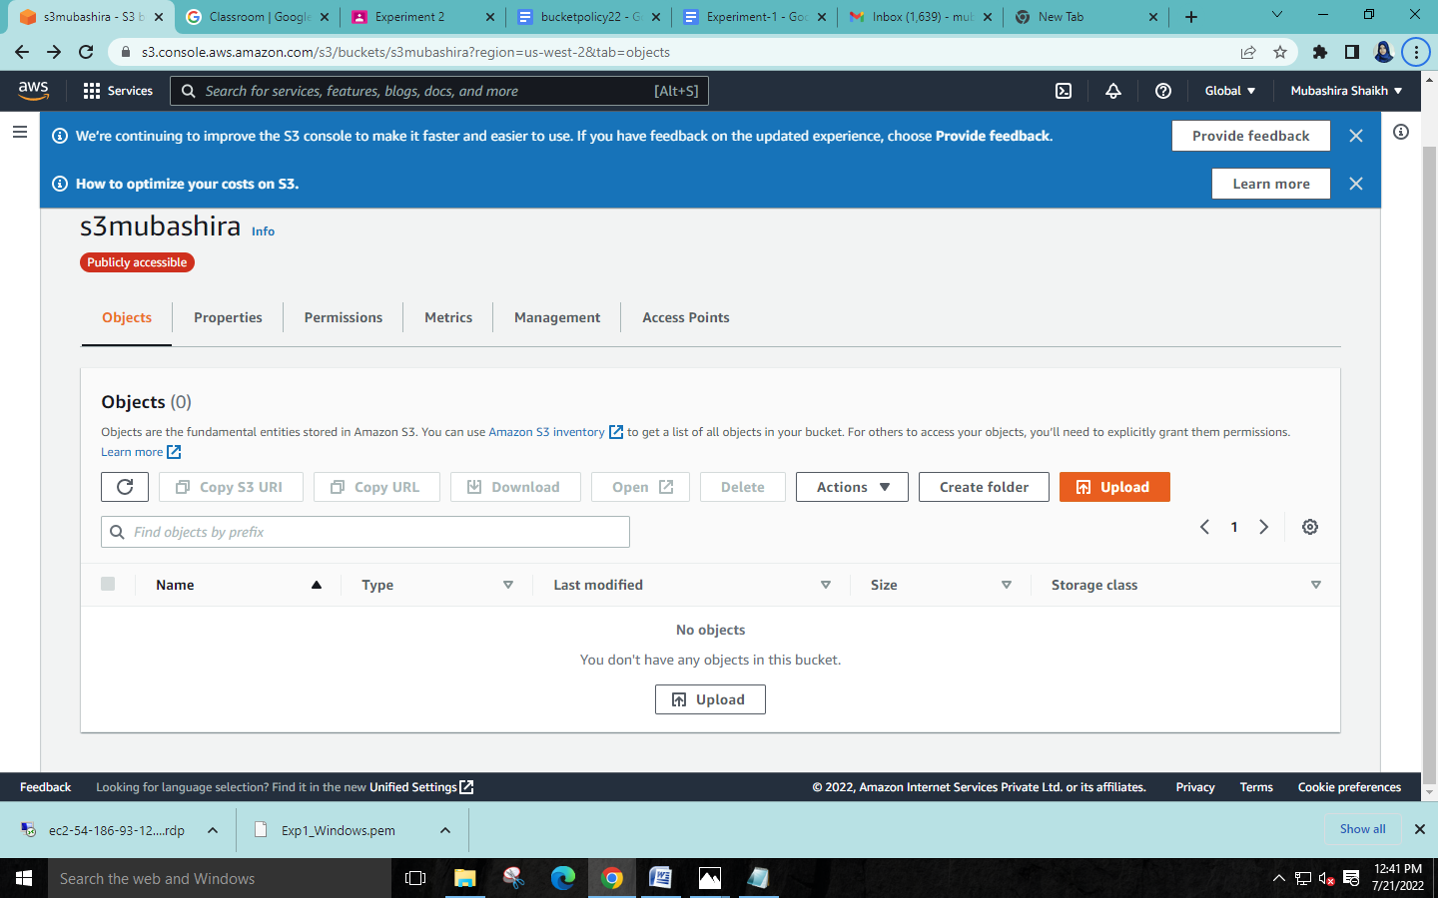

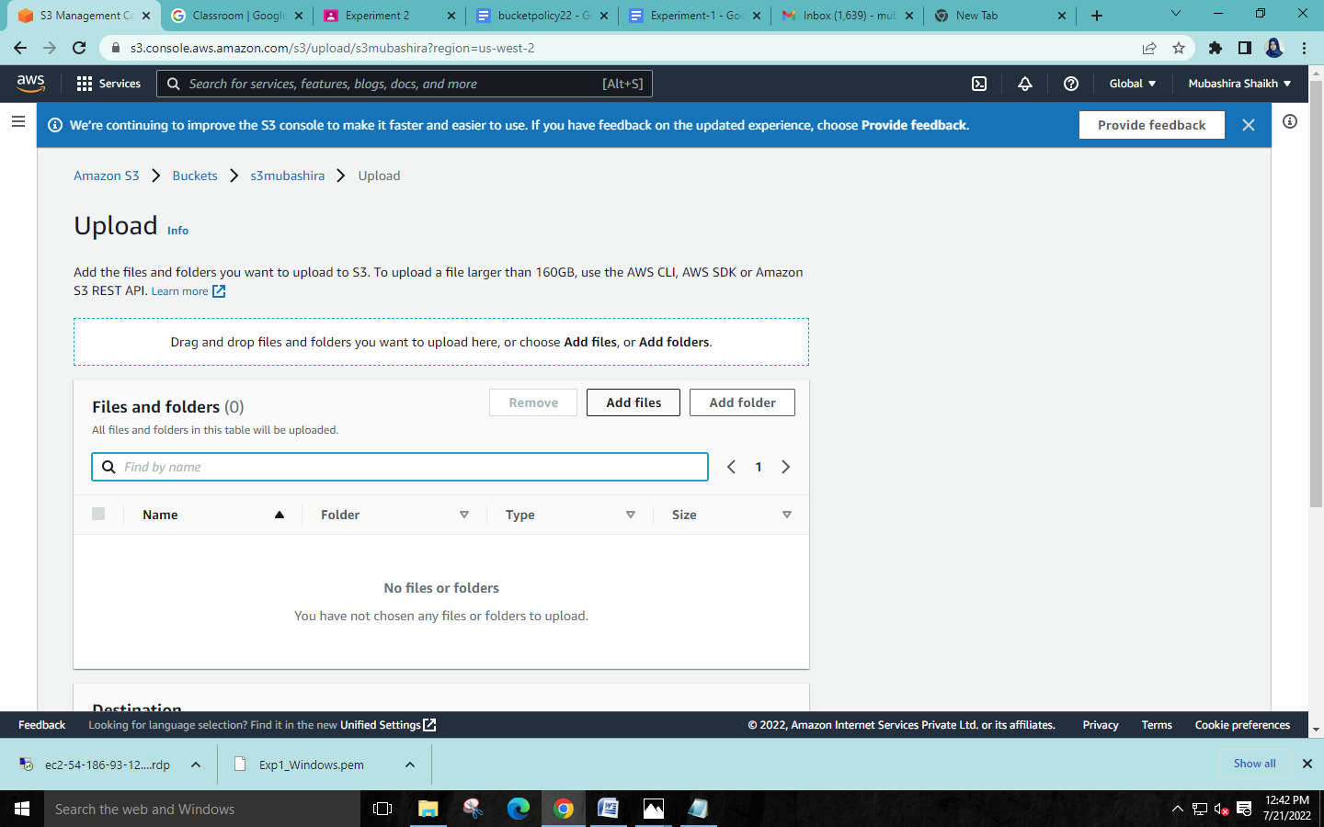

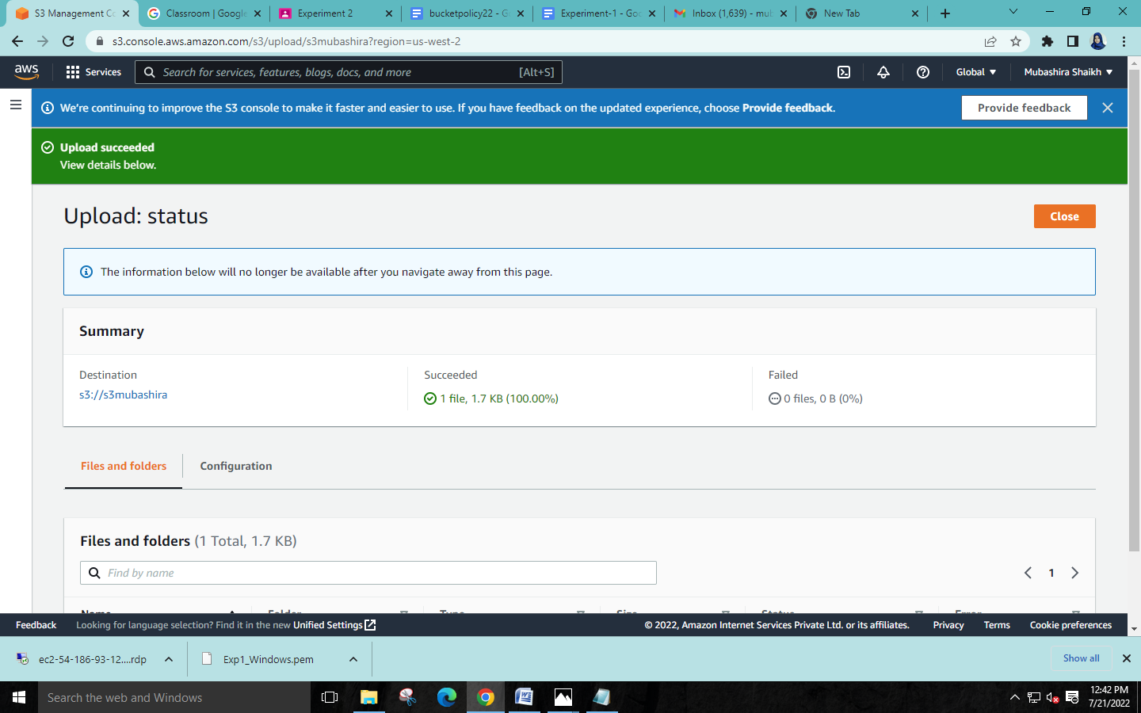

**Step 10: Now select the uploaded html object and copy the URL.**

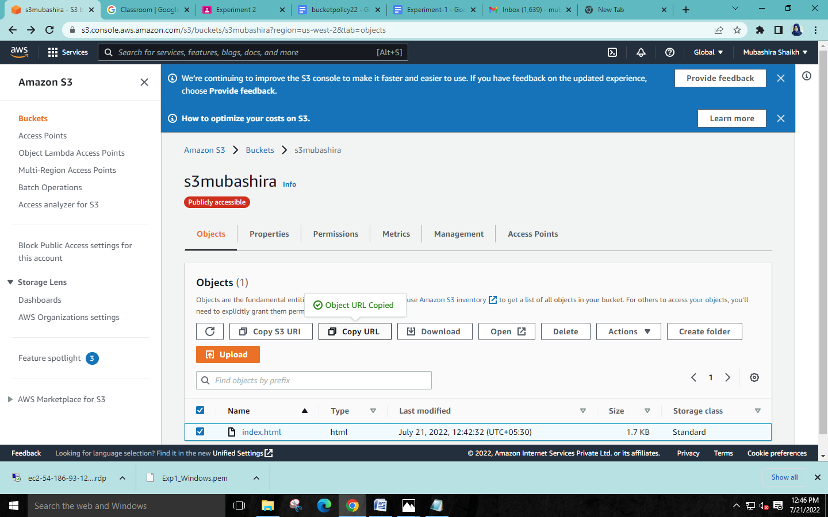

**Step 11: Paste the URL in a web browser and the web page will be displayed.**

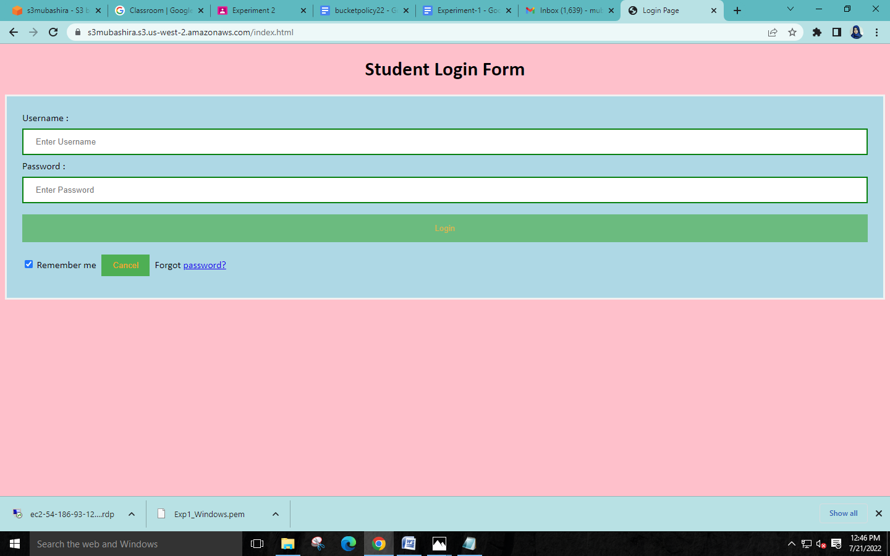

**Step 12: After closing the web page, go to buckets and delete all objects from the bucket.**

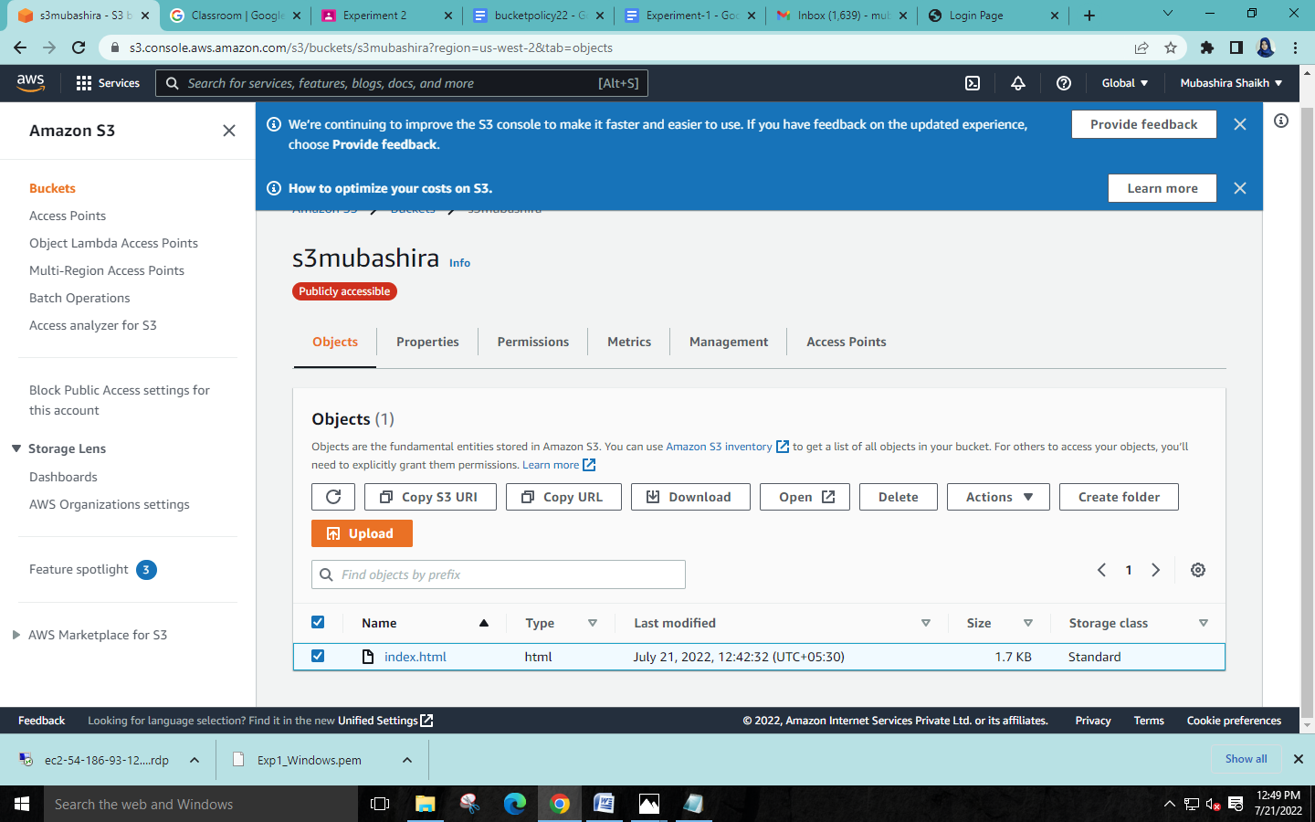

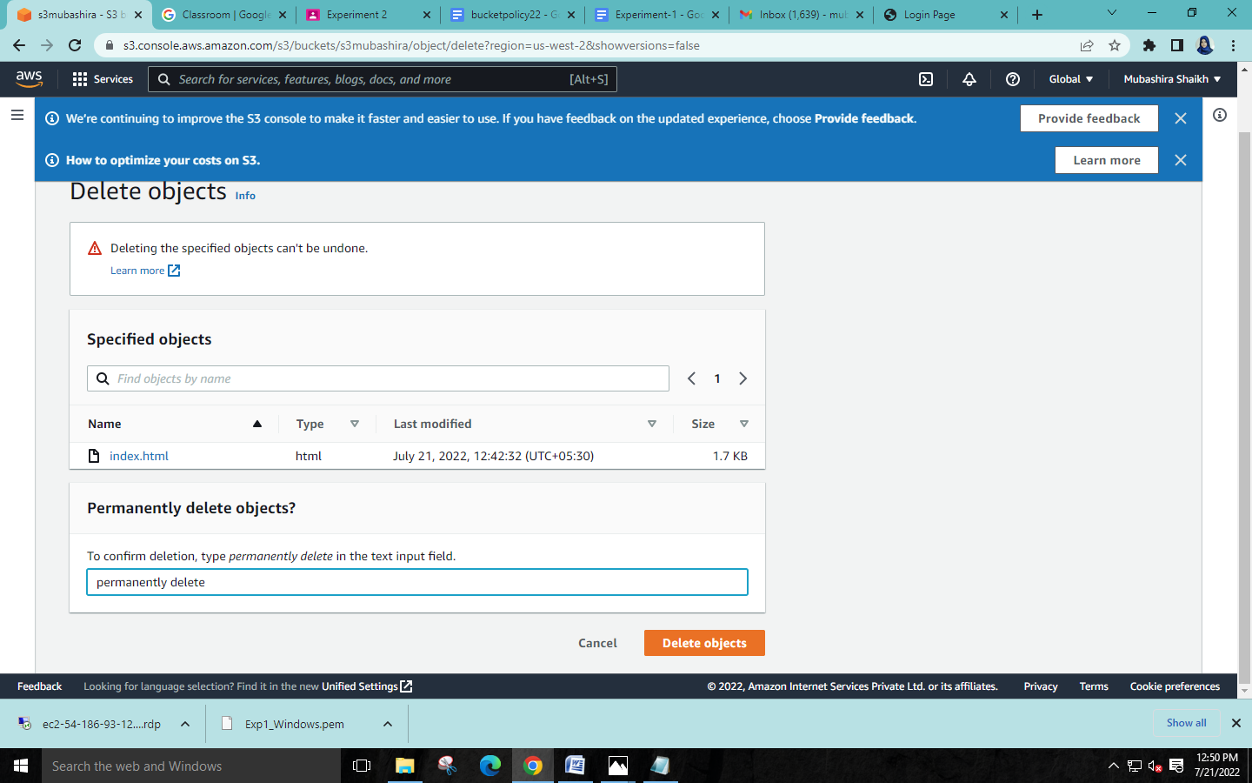

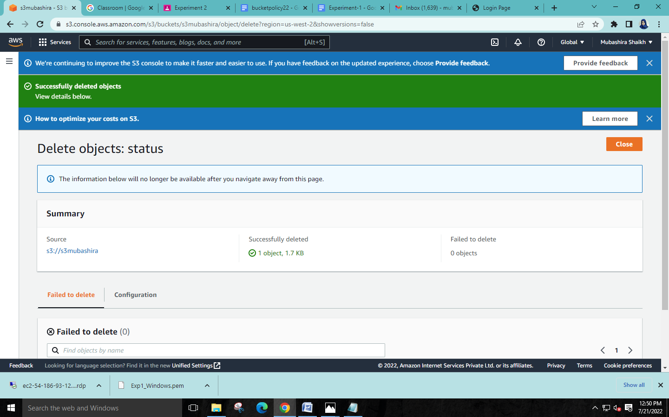

**Step 13: Then select the empty bucket and delete it.**

